Practices for Lesson 8: Manage Siebel Clients and Tools

Practices for Lesson 8

Overview

In these practices, we will explore the Siebel Web Client and the Siebel Developer Web Client in different modes. Further, you will learn to create and edit records in UI Mode using the standard Interactive mode.

**Practice 8-1: Exploring Developer and Web Client**

Overview

In this practice, you will explore the Siebel Web Client and the Siebel Developer Web Client in different modes.

Assumptions

You should have completed the Practices of Lesson 7.

**Tasks**

1. Starting the Siebel App Web Client.
2. Open the browser, enter Apps URL   
    http://<<public-ip-siebel-app>>:4430/Siebel/apps/sales/enu   
    public ip will be provided by the Instructor.
3. Enter   
   User ID - SADMIN   
   Password – XXXX (Will be provided by the instructor).
4. Click **Login**.   
   Graphical user interface, application

   Description automatically generated  
   This is a "thin" client. It uses a web browser and goes through the Siebel Enterprise components to access the Siebel data. Because you are running Open UI you can use any compliant browser.
5. In the main menu, click on **Accounts** and navigate **to Account List**
6. Navigate to **Accounts,** click **Accounts List.**
7. You need to use Chrome or Firefox as browser.
8. You will see that the layout of the screen is very similar to the High Interactivity client as shown below.

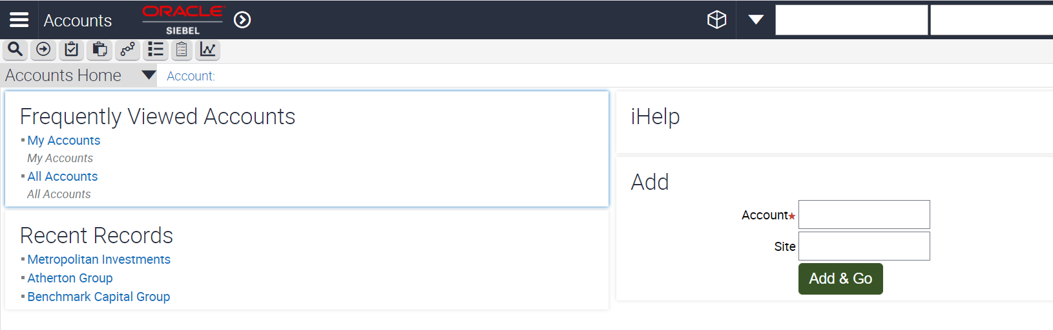

1. Click **Account List** from the second level menu. Query **Name = TEC Web Client**.

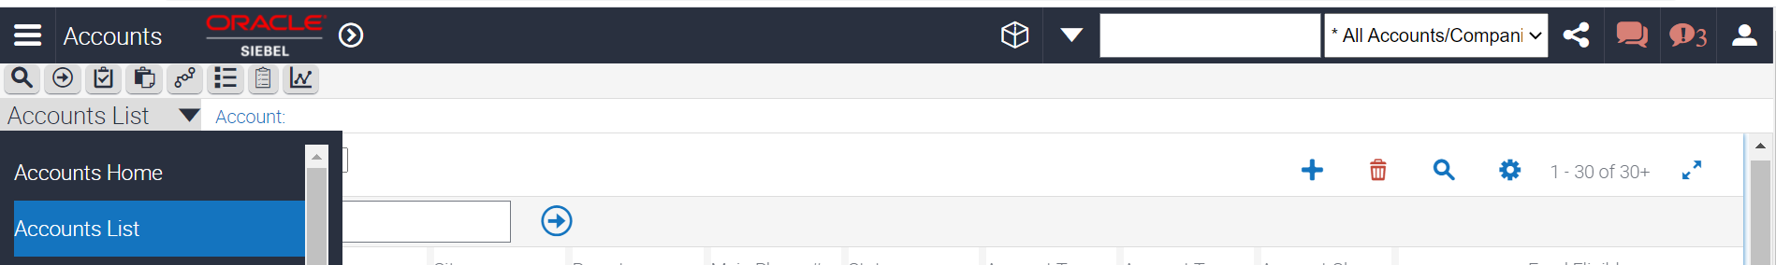

1. You will see that there is no record returned.
2. In the application-level menu, select **Help,** click **Technical Support**.

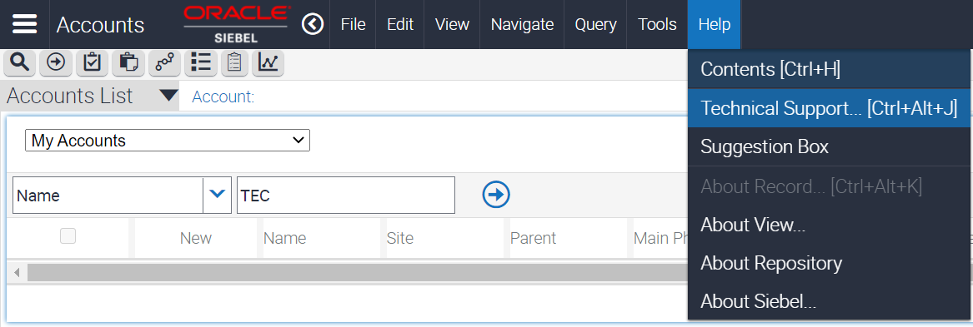

1. You will see the Connect String and Repository File.

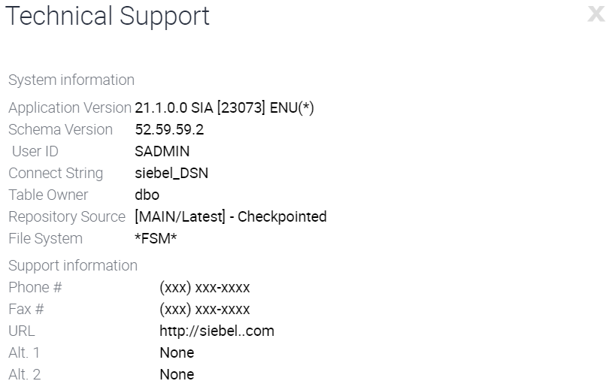

**Note:** This is the path to the Siebel repository file in the Siebel Client directory. Note that regardless of the database that you connect to, the client application uses the same directory and files (such as .cfg, .srf, .exe and so on).

1. The **User ID = SADMIN**. This is the Siebel ID you used to log into the application. SADMIN is defined in the server and sample database.
2. Click **OK.**

Practice 8-2: Exploring Open UI Mode

**Overview**

In this practice, you will create and edit records in UI Mode using the standard Interactive mode.

Assumptions

You should have completed the Practice 8-1.

Tasks

1. Start the Siebel APP Web Client using standard-interactivity mode.  
   Login as SADMIN user.

1. Starting a new record.
2. Use the **Site Map** to navigate to **Accounts > All Accounts**.   
   Note that there is no link bar so you need to use the Site Map.
3. If prompted to run **MessageBar**, click **Cance**l.
4. Click **New.**
5. You will be redirected to a form applet for your data entry.
6. Set **Name = TEC Account Standard**.
7. Working with picklists.a. Set the **Status = Contract Pending**.   
   b. In the Parent field, click the **select button.**   
   c. Select an account.   
   d. Click **OK.**
8. Saving a record
9. Before you move to another applet, you must explicitly save your changes. Click **Save** in the upper applet.
10. You are navigated back to the list applet.
11. Working with MVGs
12. In the lower list applet in the Address field, click the **select button**.
13. Verify that the MVG applet appears differently from the high-interactivity mode. It is not a shuttle applet with a list on the left and the right.
14. Click **New**.
15. Click the **check box** at the front of an address to select it. You cannot just select the record or line.
16. Click **OK.**
17. Scroll to the right if needed and click **OK**
18. In the lower list applet, click **Save** to save the record.
19. Exploring the controls
20. Click the **Opportunities** from main menu.
21. Click the "**My Opportunities**" link on the home page.
22. In the bottom applet, click **New.**
23. Set **Name = TEC Standard**.
24. In the Revenue field, click the **select** button.
25. In the Amount field, **click the calculator** button.
26. Click the 9 button three times and then **click Save**.
27. Click **OK**.
28. Click to the **top applet**.
29. Click **OK** to save your changes.
30. In the bottom applet, **click in the Description field**.
31. Verify that there is no text button.
32. In the bottom applet in the Close Date field, **click the calendar button**.
33. Click 27 to select the **27th day of the month**.
34. Click **Save.**
35. In the applet, click **Save**
36. Service Requests
37. Navigate to **Service > My Service Requests**.
38. Select the **second record** (or one that has status = Open).
39. Verify the value for Summary.
40. Set **Summary = AAA**.
41. Try to step off the record.
42. Click **OK** to discard your changes.
43. From the application-level menu, select **File > Log Out** to exit the application.

Practice 8-3: Explore Siebel Mobile

**Overview**

In this practice, you will explore Siebel Mobile Apps.

Assumptions

You should have completed the Practices of Lesson 3.

Tasks

1. Start the Siebel APP Web Client using standard-interactivity mode.  
   Login as SADMIN user.

1. Exploring the Components
2. Use the Site Map to navigate to **Administration – Mobile**
   1. In the second level menu – enter **Server Components Administration**.
   2. Observer the **Service Name and Application Name** to be posted.
3. Session Administration
4. Now, in the second level menu – move to **session administration**
   1. You can refer **Sync status**
   2. Down applet shows **sync sessions with size and patch of data**.
5. Application Administration
6. Now in second level menu, choose **application administration**
   1. The business component filters are displayed for the default sync modes.
   2. Click **on settings** in second level menu to explore the settings for the components.
   3. Note the directory of the application by the property name “**application settings”**
7. Conflict Administration
8. In case of transactions managing conflict – conflict administration page gets the view.
   1. Choosing the **conflict administration shows transactions**.
   2. No transactions are shown
   3. Observe the actions buttons for Ignore and reapply for transactions.
   4. You will see Audit trail in the third level menu to trace the conversation.
9. User Administration
10. In the second level menu, choose **user administration**.
    1. This will list users
    2. Observe Siebel administrator as one of the users.

Practice 8-4: Explore Web Browser Settings from UI Client

**Overview**

In this practice, you will explore Web Browser Settings from Siebel Apps

Assumptions

You should have completed the Practice of Lesson 8-3.

Tasks

1. Start the Siebel APP Web Client using standard-interactivity mode.  
   Login as SADMIN user.

1. Exploring Component
   1. Use the Site Map to navigate to **Administration – Web Browser**
   2. Choose **Browsers** from second level menu
      1. Displays list of Browsers configured through the mobile client.
   3. Click on **Firefox 4.0**
      1. Capabilities of browser gets engaged below.
      2. In the second level menu , choose **control event combinations**
         1. Observe the capabilities for the event which defines the Event and Event name and description.
      3. In the second level menu, **choose capabilities**
         1. Details of the capabilities of the applications are shown.
         2. Observe the capability Cookie Allowed
      4. In the second level menu, **choose events**
         1. These events are allowed events or tracked events by Siebel apps. List of events are tracked.
         2. Observe the event onload.
      5. In the second level menu, **choose controls**
         1. The controls specify the scope of UI controls compatible with the application.
         2. Each control has defined capability defined down the applet.
         3. Observe a control called Object which is defined for custom control and 3rd party controls.